**Condensed Chapter Material**

**Male Genitalia**

***Anatomy:***

Structures: Penis, testicles, epididymis, scrotum, prostate gland and seminal vesicles.

1. 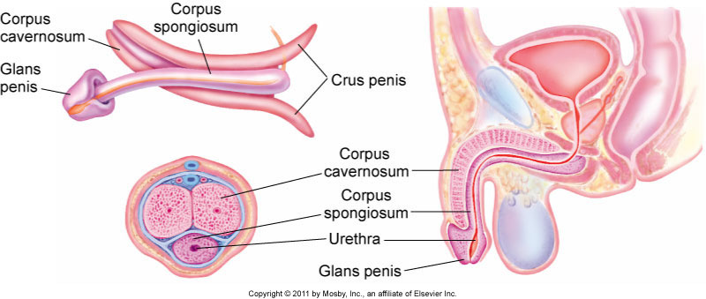Penis: Consists of two corpora cavernosa (makes up dorsum and sides of penis which engorges during erection) and corpus spongiosum (ventral aspect, contains urethra).

Corpus spongiosum expands at distal end to form glans penis (covered by prepuce also known as foreskin in uncircumcised patients). Skin of penis is thin, redundant and free of subcutaneous fat.

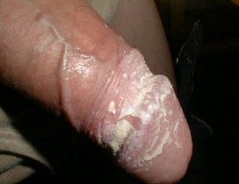

In uncircumcised patients, smegma is formed (combination of secretion of sebaceous material by glans and desquamation of epithelial cells) and appears as cheesy white material on glans (picture).

1. Scrotum: like penis, is darkly pigmented when compared to the body skin.
   1. 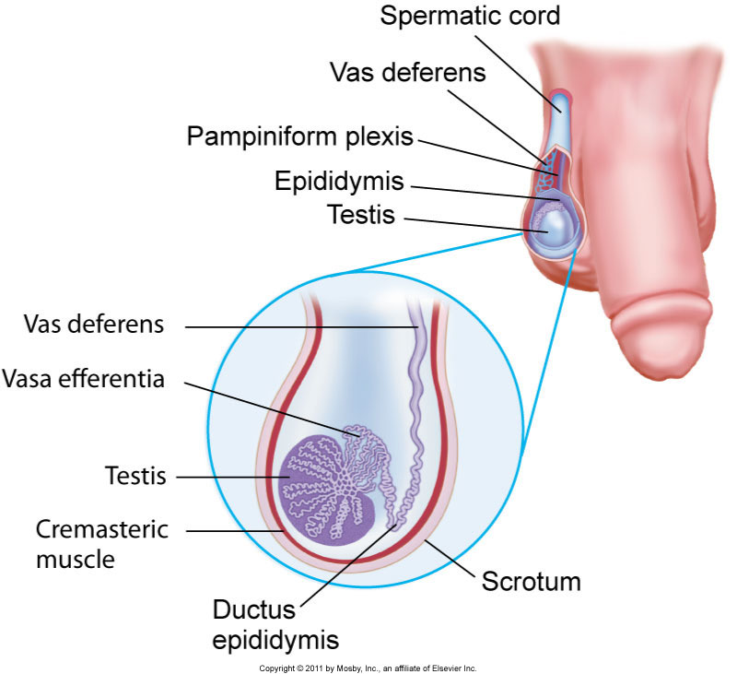Divided by septum, creating two pendulous sacs
      1. Each sac contains testis, epididymis, spermatic cord, and cremasteric muscle (allows scrotum to relax/contract, helping maintain temperature)
2. Testicles: Ovoid shaped structure which produces spermatozoa and testosterone.
3. Epididymis: soft comma-shaped structure on the posterolateral and upper aspect of testis. Functions as storage, place of maturation and transit of sperm.
4. Vas deferens: begins at tail of epididymis, ascends the spermatic cord, travels through inguinal canal, and unites with seminal vesicle to form ejaculatory duct
5. Prostate gland: surrounds urethra at bladder neck, produces major volume of ejaculatory fluid (contains fibrinolysin which liquefies coagulated semen to assist in proper motility)

Infants: At 12 weeks gestation, sexual differentiation has occurred. Testes descend from retroperitoneal space in the third trimester through the inguinal canal into the scrotum. In uncircumscribed males, the complete separation of prepuce (foreskin) from glans occurs at 3-4 years.

Changes during puberty: Increased testicular size and thinning/reddening of scrotum. Penis enlarges in length and width. Pubic hair develops. The penis itself is not covered with hair and the scrotum has scant hair.

Older adults: Pubic hair becomes finer and less abundant.

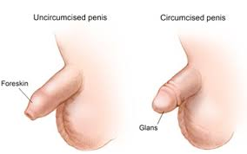

***Examination:***

**Inspection and palpation:**

1. Penis
   1. Note if patient is circumcised or not
      1. If patient is not, retract foreskin. It should retract easily and smegma may be seen. Reposition foreskin after examination
      2. If patient is circumcised, glans is exposed and appears erythematous and dry with no smegma present

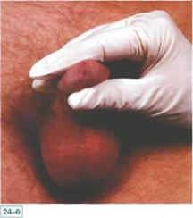

1. Urethral meatus
   1. Appears as a slit on the ventral surface just mm from tip of glans
   2. Press glans between thumb and forefinger to open orifice. Opening should be glistening and pink. Bright erythema and discharge are abnormal
2. Scrotum
   1. Often darker pigmentation than the body skin and coarser.
   2. Scrotum is often asymmetric due to longer left spermatic cord (left side often lower)
   3. Lumps in scrotal skin often due to sebaceous cysts
3. Testes
   1. Palpate testes using thumb and first two fingers
      1. Should be sensitive to gentle compression but non tender
      2. Testes should be smooth, rubbery and free of nodules.
      3. Palpate epididymis (on the posterolateral surface of testis)-should be smooth, non-tender
      4. Palpate vas deferens-contains accompanying arteries and veins. Should feel smooth and discrete with no lumps.



1. Cremasteric reflex
   1. Stroke inner thigh with handle of reflex hammer or finger
      1. Scrotum and testicle should rise on ipsliateral side.
2. Hernia
   1. Insert your finger into lower part of scrotum and move upward along vas deferens into inguinal canal. You should feel an oval external ring. Ask patient to cough.

**Types of Hernia: Direct vs Indirect**

Hernias are protrusion of the peritoneal-lined sac (abdominal organs or omentum) through a defect in the abdominal wall. These arise along the course the testicle traveled as it exited the abdomen into the scrotum. They can cause soft swelling/bulge in inguinal area, and may have pain. Strangulated hernias occur when blood supply of protruded tissue is compromised.

1. 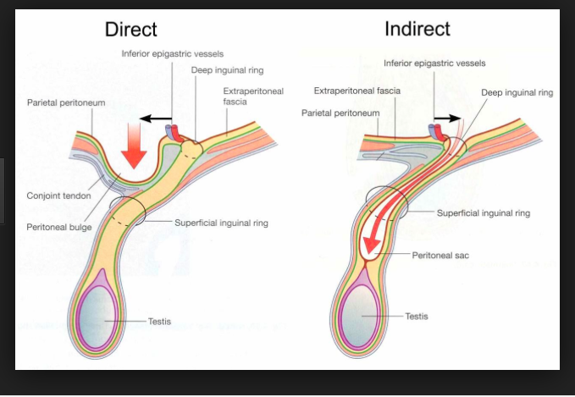Indirect Inguinal hernia:
   1. Most common type of hernia. Males=Females. Often in children
   2. Hernia goes through internal/deep inguinal ring and can remain in the canal, exit the external/superficial ring, and pass into scrotum. May be bilateral
   3. Presents as a soft swelling in area of internal ring with pain on straining. Hernia touches fingertip on examination
2. Direct Inguinal Hernia:
   1. Less common than indirect hernia. Males>Females. In older individuals (>40 years)
   2. Hernia goes through external/superficial inguinal ring, located in region of Hesselbach’s triangle, rarely enters scrotum
   3. Presents as bulge in Hesselbach’s triangle, usually painless, easily reduced, bulges anteriorly, pushes against side of finger on examination.

**Children:**

**Inspection and Palpation:**

1. Penis
   1. Inspect for size, lesions, swelling, inflammation and malformation
   2. Retract foreskin (fully retractable by 3 or 4 years), without forcing it. Inspect glans and urethral meatus. Penis may appear small and obscured by fatty tissue.
   3. Signs of sexual abuse include: swollen, tender or bruised penis.
   4. Enlarged penis without increase in testicular size occurs with precocious puberty
2. 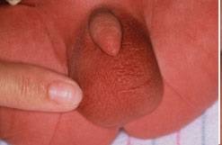Scrotum
   1. Inspect for size, shape, color
   2. Identify whether testicles have descended into scrotum
      1. Rugae indicate descent in infancy
      2. Palpate scrotum to identify testes and epididymis
      3. Signs of sexual abuse: bruising of scrotum
3. Testes
   1. Some testicles are very retractile and hard to find
      1. Have patient sit in tailor position with legs crossed to increase pressure of abdominal wall to help push testicles into scrotum. (this also accentuates inguinal hernias)
      2. If scrotum remains small and flat, consider cryptorchidism aka undescended testes
   2. Signs of tumor: hard and enlarged mass
   3. Signs of testicle torsion (twisting of spermatic cord impeding blood flow to testicle) include acute swelling of scrotum with discoloration
   4. Signs of epididymitis (inflammation of epididymis) include acute swelling without discoloration and thickened epididymis.